Walchand College of Engineering, Sangli Department of Computer Science and Engineering

Class: Final Year (Computer Science and Engineering)

Year: 2022-23 Semester: 1

Course: High Performance Computing Lab

Practical No. 10

Exam Seat No: 2019BTECS00033 – Teknath Jha

Title of practical: CUDA

Github Link https://github.com/Teknath-jha/HPC-LAB-2019BTECS00033/blob/main/Assignment-10/Q1.cu

Problem Statement 1: Implement Matrix-matrix Multiplication using global memory in CUDA C. Analyze and tune the program for getting maximum speed up. Do Profiling and state what part of the code takes the huge amount of time to execute.

Screenshots:

Sequential Time on PC: 17343508000 ns

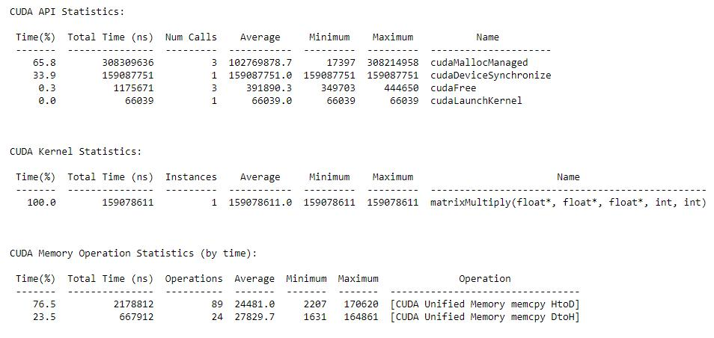
<<<8, 32>>>

<<<8, 24>>>

1 | P a g e

Final Year: High Performance Computing Lab 2022-23 Sem I

Walchand College of Engineering, Sangli Department of Computer Science and Engineering
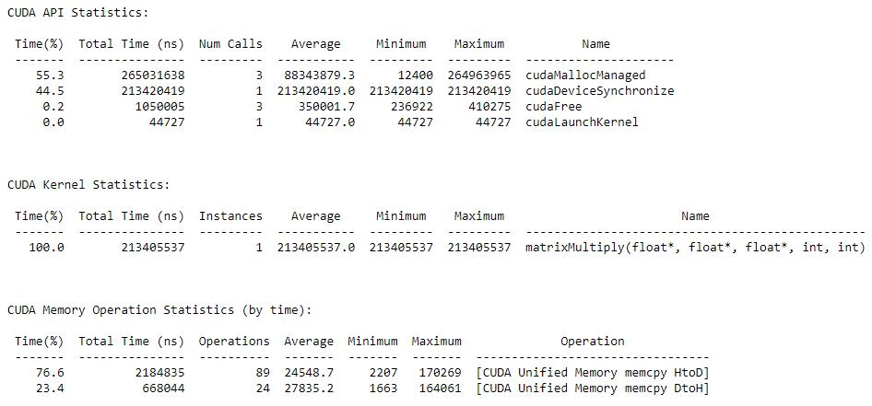

<<<8, 16>>>
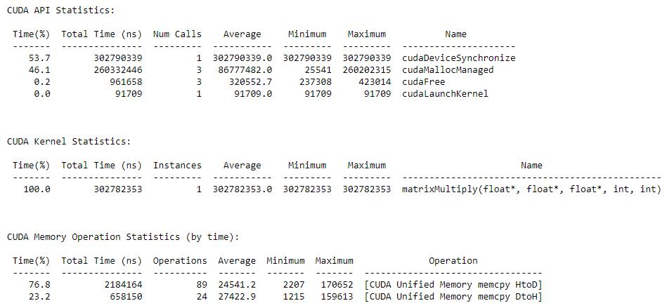

<<<6, 32>>>

2 | P a g e

Final Year: High Performance Computing Lab 2022-23 Sem I

Walchand College of Engineering, Sangli Department of Computer Science and Engineering
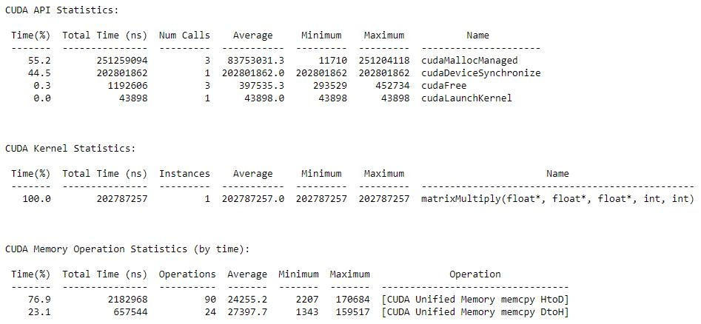

<<<4, 32>>>
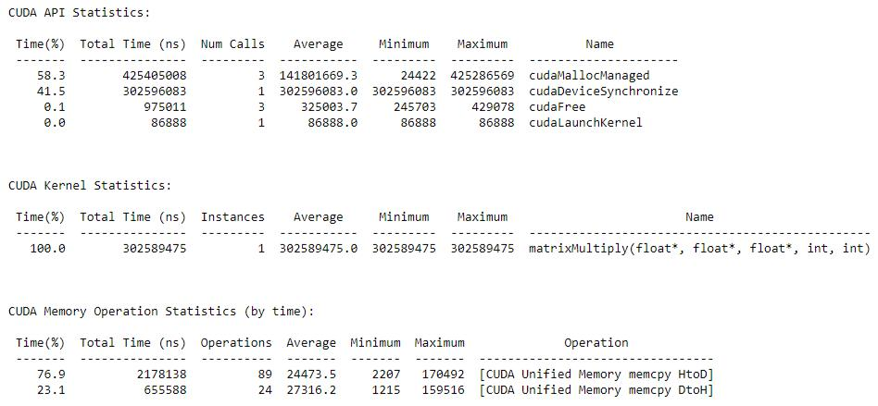

 | Speedup
<<<8, 16>>> | 57.28045
<<<8, 24>>> | 81.27019
<<<8, 32>>> | 109.0248
<<<6, 32>>> | 85.52563
<<<4, 32>>> | 57.31696

Execution time:

As expected, the execution time of kernel decreases as the total threads (blocks * threads) increases.

3 | P a g e

Final Year: High Performance Computing Lab 2022-23 Sem I

Walchand College of Engineering, Sangli Department of Computer Science and Engineering

Total time taken by program also follows a similar trend.

Memory allocation and deallocation:

All instances seem to follow random fluctuations since the same amount of memory is being allocated outside any parallel region. But is pretty much constant

Memory Migration in Unified Memory:

Copying memory from Host to Device takes almost 3.5 times more time than Device to Host.

But the time required for these operations is pretty much constant across changed kernel configuration.

Most time consuming part:

Allocation of memory by cudaMallocManaged takes largest time in the entire program in most cases.

4 | P a g e

Final Year: High Performance Computing Lab 2022-23 Sem I

Walchand College of Engineering, Sangli Department of Computer Science and Engineering

Problem Statement 2: Implement Matrix-Matrix Multiplication using shared memory in CUDA C. Analyze and tune the program for getting maximum speed up. Do Profiling and state what part of the code takes the huge amount of time to execute.

Screenshot:

Sequential Time on PC: 17343508000 ns

<<<8, 32>>>
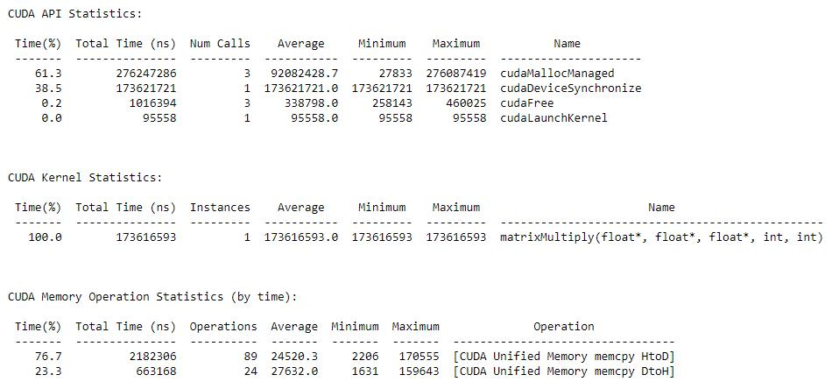

<<<8, 24>>>
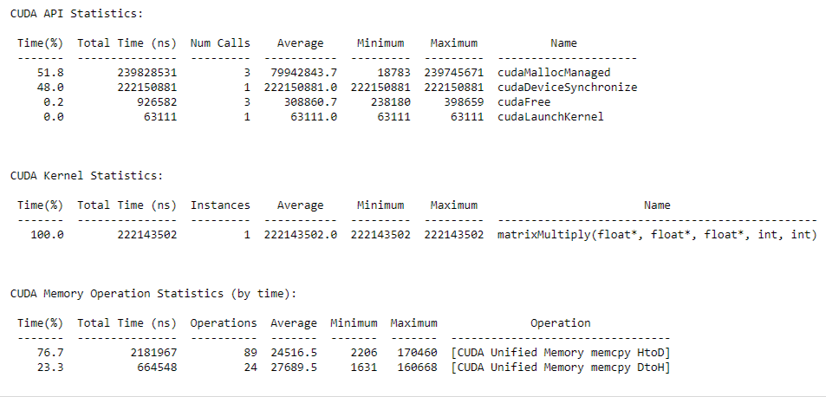

5 | P a g e

Final Year: High Performance Computing Lab 2022-23 Sem I

Walchand College of Engineering, Sangli Department of Computer Science and Engineering

<<<8, 16>>>
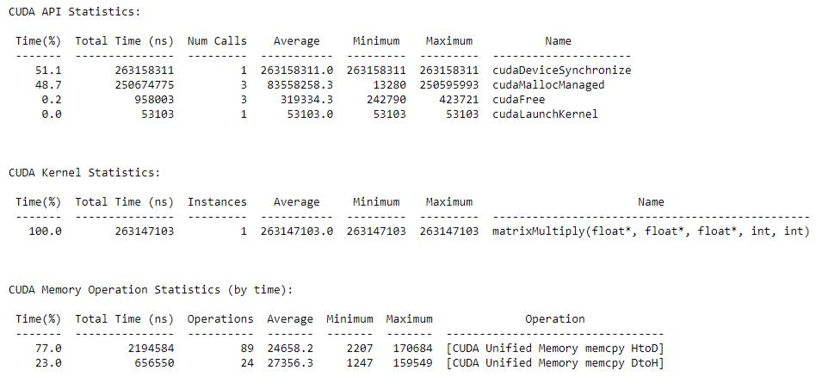

<<<6, 32>>>
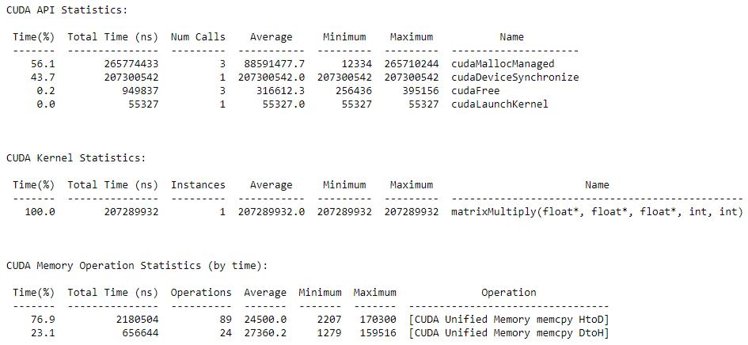

<<<4, 32>>>

6 | P a g e

Final Year: High Performance Computing Lab 2022-23 Sem I

Walchand College of Engineering, Sangli Department of Computer Science and Engineering
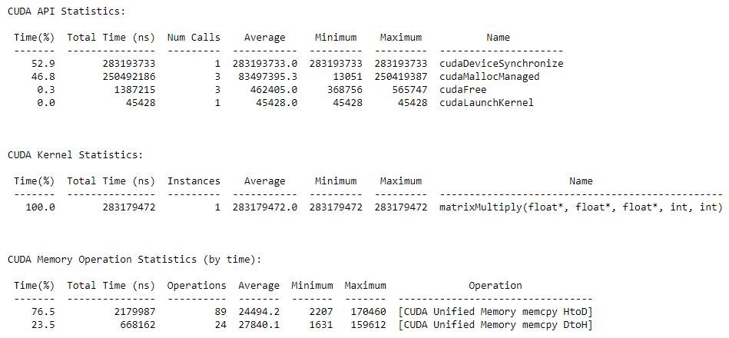

 | Speedup
<<<8, 16>>> | 65.90803
<<<8, 24>>> | 78.07344
<<<8, 32>>> | 99.89545
<<<6, 32>>> | 83.66787
<<<4, 32>>> | 61.24564

GITHUB : https://github.com/Teknath-jha/HPC-LAB-2019BTECS00033/blob/main/Assignment-10/Q2.cu

Execution time:

As expected, the execution time of kernel decreases as the total threads (blocks * threads) increases.

Total time taken by program also follows a similar trend.

Memory allocation and deallocation:

All instances seem to follow random fluctuations since the same amount of memory is being allocated outside any parallel region. But is pretty much constant

Memory Migration in Unified Memory:

Copying memory from Host to Device takes almost 3.5 times more time than Device to Host.

But the time required for these operations is pretty much constant across changed kernel configuration.

Most time consuming part:

Allocation of memory by cudaMallocManaged takes largest time in the entire program in most cases.

7 | P a g e

Final Year: High Performance Computing Lab 2022-23 Sem I

Walchand College of Engineering, Sangli Department of Computer Science and Engineering

Problem Statement 3: Implement Prefix sum using CUDA C. Analyze and tune the program for getting maximum speed up. Do Profiling and state what part of the code takes the huge amount of time to execute.

Screenshots:

Sequential Time: 3000000

<<<1, 32>>>
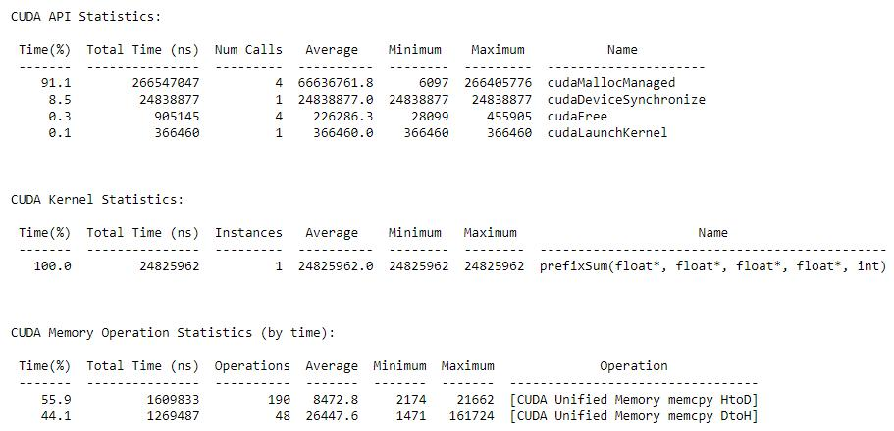

<<<1, 24>>>

8 | P a g e

Final Year: High Performance Computing Lab 2022-23 Sem I

Walchand College of Engineering, Sangli Department of Computer Science and Engineering
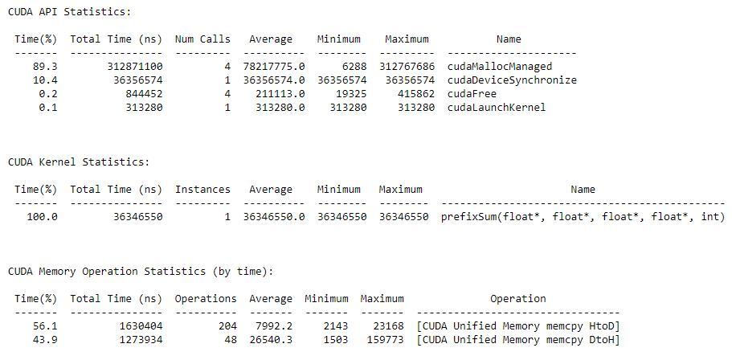

<<<1, 16>>>
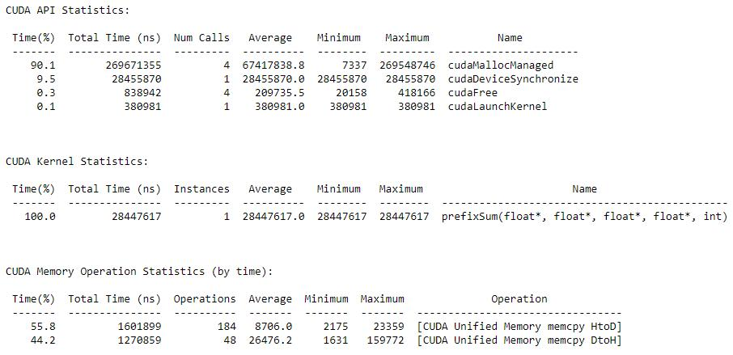

 | Speedup
<<<1, 16>>> | 0.105457
<<<1, 24>>> | 0.082539
<<<1, 32>>> | 0.120841

GitHub Link : https://github.com/Teknath-jha/HPC-LAB-2019BTECS00033/blob/main/Assignment-10/Q3.cu

Execution time:

As expected, the execution time of kernel decreases as the total threads (blocks * threads) increases.

Total time taken by program also follows a similar trend.

9 | P a g e

Final Year: High Performance Computing Lab 2022-23 Sem I

Walchand College of Engineering, Sangli Department of Computer Science and Engineering

Memory allocation and deallocation:

All instances seem to follow random fluctuations since the same amount of memory is being allocated outside any parallel region. But is pretty much constant

Memory Migration in Unified Memory:

Copying memory from Host to Device takes almost 1.33 times more time than Device to Host.

But the time required for these operations is pretty much constant across changed kernel configuration.

Most time consuming part:

Allocation of memory by cudaMallocManaged takes largest time in the entire program in most cases.

10 | P a g e

Final Year: High Performance Computing Lab 2022-23 Sem I

Walchand College of Engineering, Sangli Department of Computer Science and Engineering

Problem Statement 4: Implement 2D Convolution using shared memory using CUDA C. Analyze and tune the program for getting maximum speed up. Do Profiling and state what part of the code takes the huge amount of time to execute.

Screenshots:

Sequential Time: 248518000

<<<(32, 32), (32, 32)>>>
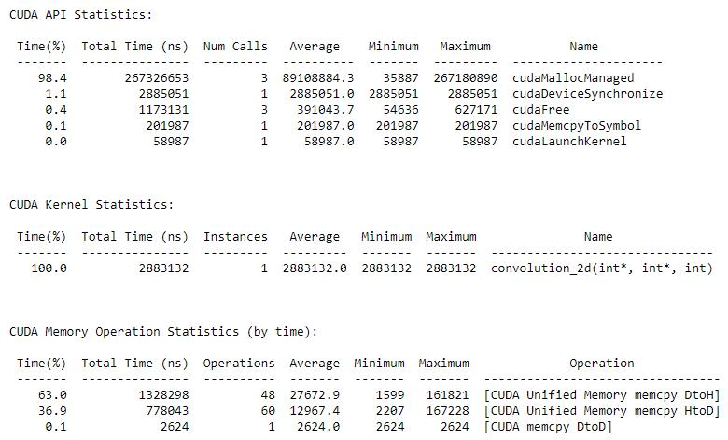

<<<(64, 64), (16, 16)>>>

11 | P a g e

Final Year: High Performance Computing Lab 2022-23 Sem I

Walchand College of Engineering, Sangli Department of Computer Science and Engineering
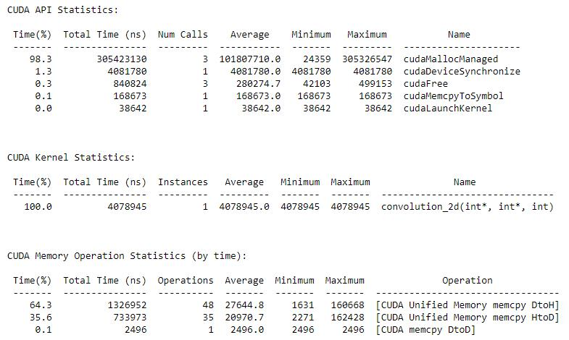

<<<(128, 128), (8, 8)>>>
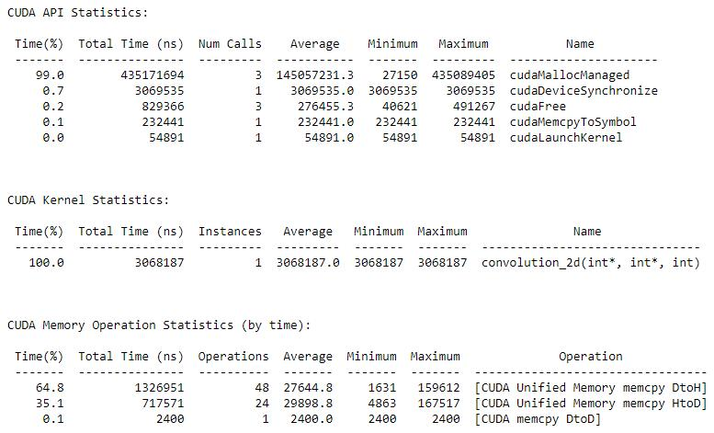

12 | P a g e

Final Year: High Performance Computing Lab 2022-23 Sem I

Walchand College of Engineering, Sangli Department of Computer Science and Engineering

 | Speedup
<<<(32, 32), (32, 32)>>> | 86.19723
<<<(64, 64), (16, 16)>>> | 60.92703
<<<(128, 128), (8, 8)>>> | 80.99832

Github Link: https://github.com/Teknath-jha/HPC-LAB-2019BTECS00033/blob/main/Assignment-10/Q4.cu

Memory allocation and deallocation:

All instances seem to follow random fluctuations since the same amount of memory is being allocated outside any parallel region. But is pretty much constant

Memory Migration in Unified Memory:

Copying memory from Host to Device takes almost 1.8 times more time than Device to Host.

But the time required for these operations is pretty much constant across changed kernel configuration.

Most time consuming part:

Allocation of memory by cudaMallocManaged takes largest time in the entire program in most cases.

13 | P a g e

Final Year: High Performance Computing Lab 2022-23 Sem I

